1**. Scenario: You are working on a project that involves analyzing student performance data for a class of 32 students. The data is stored in a NumPy array named student_scores, where each row represents a student and each column represents a different subject. The subjects are arranged in the following order: Math, Science, English, and History. Your task is to calculate the average score for each subject and identify the subject with the highest average score.**

**Question: How would you use NumPy arrays to calculate the average score for each subject and determine the subject with the highest average score? Assume 4x4 matrix that stores marks of each student in given order.**

import numpy as np

student_scores = np.array([

[85, 90, 78, 92],

[88, 76, 85, 80],

[90, 85, 88, 86],

[70, 80, 75, 85]

])

subjects = ['Math', 'Science', 'English', 'History']

avg = np.mean(student_scores, axis=0)

print("Average scores:", avg)

print("Highest average subject:", subjects[np.argmax(avg)])

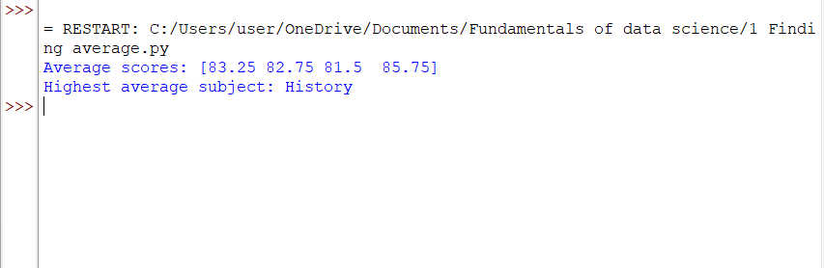

**2. Scenario: You are a data analyst working for a company that sells products online. You have been tasked with analyzing the sales data for the past month. The data is stored in a NumPy array. Question: How would you find the average price of all the products sold in the past month? Assume 3x3 matrix with each row representing the sales for a different product**

import numpy as np

sales_data = np.array([[120,130,110],[100,90,95],[150,160,170]])

print("Average price:", np.mean(sales_data))

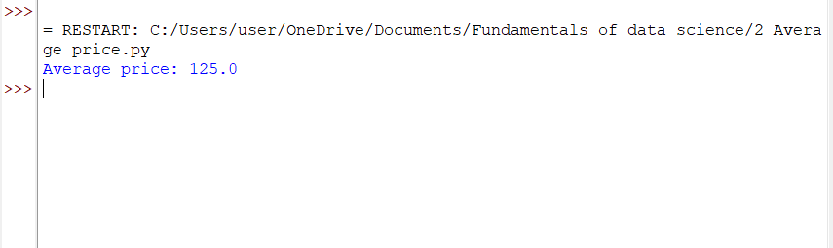

3. Scenario: You are working on a project that involves analyzing a dataset containing information about houses in a neighborhood. The dataset is stored in a CSV file, and you have imported it into a NumPy array named house_data. Each row of the array represents a house, and the columns contain various features such as the number of bedrooms, square footage, and sale price. Question: Using NumPy arrays and operations, how would you find the average sale price of houses with more than four bedrooms in the neighborhood?